|  |
| --- |
|  |
| **Monitoring the status of the garbage containers** |
| Requirement specification |
|  |

|  |
| --- |
|  |

**Authors:** Xavier Cerqueda Puig

Bernat Garcia Torrentsgeneros

Pierre Biojoux

Quentin Studeny

Junyoung Bang

Joonas Luukkanen

**Supervisor:** Torben Gregersen

**Date:** 10/10/2016

# 1. Table of contents

1. Table of contents 2

2. Introduction 3

2.1 Actor/Context Diagram 3

2.2 Actors Description 3

3. Use cases 4

3.1 Use cases diagram 4

3.2 Use case 1: Authenticate 5

3.3 Use case 2: Check status of garbage bins 6

3.4 Use case 3: Check position of the trash containers 7

3.5 Use case 4: See details of a specific garbage container 8

3.6 Use case 5: Find the best garbage collection route 9

3.7 Use case 6: Update the occupancy rate of a garbage container 10

4. Non-functional requirement 11

4.1 Robustness 11

4.2 Performance 11

4.3 Distance 11

4.4 Angle measurement 12

5. External interface requirement 12

5.1 User Interface 12

5.2 Graphical user interface 12

5.2.1 Start Screen 12

5.2.2 Map Screen 12

5.2.3 Potential additions 12

# 2. Introduction

In this document, we will describe the requirements for our project in the ITIPRJ course.

## 2.1 Actor/Context Diagram

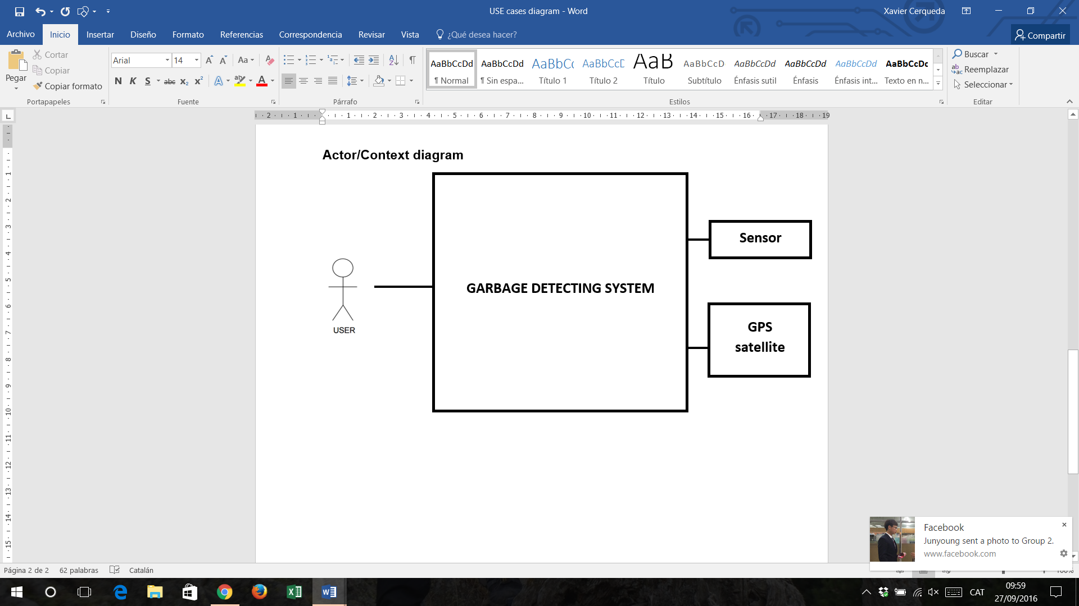

## 2.2 Actors Description

**User:** The main user are the trash collectors. He will be able to check the status and location of the garbage containers. And to prepare his collection route depending on which containers need to be emptied.

**Sensor:** Electronic device that collect data about the status of the garbage bins and send it to the microcontroller to be analysed.

**GPS Satellite:** Device responsible to receive the location signal sent by the system (GPS emitter) and analyse it.

# 3. Use cases

## 3.1 Use cases diagram

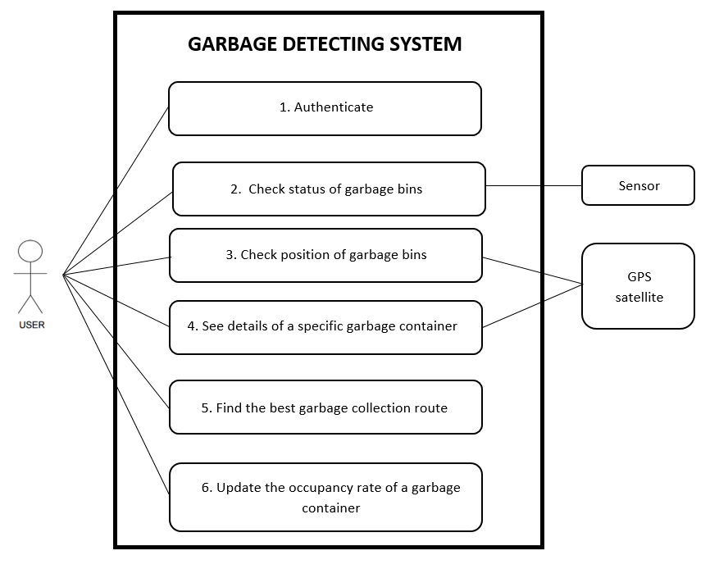

## 3.2 Use case 1: Authenticate

|  |  |
| --- | --- |
| **Name** | **Authenticate** |
| **Author** | Group 2 |
| **Date** | 20/09/2016 |
| **Goals** | Access the application |
| **Preconditions** | Have an internet connection |
| Trash collector needs a smartphone |
| **Post-condition** | The user's smartphone and the server are connected |
| **Narrative Description** | This feature allows to each trash collector who work in this company to log in to the app and prevent access to unauthorized persons |
| **Nominal Scenario** | 1: The app opens the activity of the authentication |
| 2: User fills his login and his password |
| 3: User chooses the button "Log in" |
| 4: The server checks his login and his password |
| 5: The server allows the app to open the next activity |
| **Alternative Scenario** | 2.a User decides to quite the app |
| **Error Scenario** | 4.a The login or the password is incorrect -> The app shows the message "Invalid password or login" |

## 3.3 Use case 2: Check status of garbage bins

|  |  |
| --- | --- |
| **Name** | **Check status of garbage bins** |
| **Author** | Group 2 |
| **Date** | 20/09/2016 |
| **Goals** | Know how full are garbage bins emptied |
| **Preconditions** | All the system has to work |
| Have an internet connection |
| Trash collector needs a smartphone |
| **Post-condition** | The user's smartphone and the system are connected |
| **Narrative Description** | This feature allows to each trash collector who work in this company to check how full are garbage bins and have an approximation of when they should be |
| **Nominal Scenario** | 1: The app opens the activity of the main menu |
| 2: User select "Check the status" |
| 3: The app opens the list of garbage bins |
| 4: User consults the list |
| **Alternative Scenario** | 2.a User decides to sign out |
| 2.b User chooses another option of the menu |
| 4.a User decides to return to the menu |
| **Error Scenario** | 3.a App can't update data -> The app shows the message "We can't update data, check your internet connection" |

## 3.4 Use case 3: Check position of the trash containers

|  |  |
| --- | --- |
| **Name** | **Check position of garbage bins** |
| **Author** | Group 2 |
| **Date** | 22/09/2016 |
| **Goals** | See on a map the position of trash containers |
| **Preconditions** | All the system has to work |
| Have an internet connection |
| Trash collector needs a smartphone |
| **Post-condition** | The user's smartphone and the system are connected |
| **Narrative Description** | This feature allows to each trash collector who work in this company to see on a map where are trash containers and know how full they are thanks to a colour code |
| **Nominal Scenario** | 1: The app opens the activity of the main menu |
| 2: User select "Show on map" |
| 3: The app opens the map with the location of the garbage bins |
| 4: User consults the map |
| **Alternative Scenario** | 2.a User decides to sign out |
| 2.b User chooses another option of the menu |
| 4.a User decides to return to the menu |
| **Error Scenario** | 3.a App can't find your position -> The app shows the message "We can't find your position, check your internet connection" |

## 3.5 Use case 4: See details of a specific garbage container

|  |  |
| --- | --- |
| **Name** | **See details of a specific garbage container** |
| **Author** | Group 2 |
| **Date** | 22/09/2016 |
| **Goals** | See a description of a specific garbage bin with many details |
| **Preconditions** | All the system has to work |
| Have an internet connection |
| Trash collector needs a smartphone |
| **Post-condition** | The user's smartphone and the system are connected |
| **Narrative Description** | This feature allows to each trash collector who work in this company to see details of a garbage bin to know its position, its filling and also have an approximation of the next collection |
| **Nominal Scenario** | 1: The app is running the list of garbage bins or the map |
| 2: User select a garbage bin on the map or in the list |
| 3: The app opens the activity "Details" of the garbage bin selected |
| 4: User consults details |
| **Alternative Scenario** | 2.a User doesn't choose any garbage bin |
| 4.a User decides to return to the menu |
| **Error Scenario** | 3.a App can't access to the data -> The app shows the message "We can't access to data, check your internet connection" |

## 3.6 Use case 5: Find the best garbage collection route

|  |  |
| --- | --- |
| **Name** | **Find the best garbage collection route** |
| **Author** | Group 2 |
| **Date** | 22/09/2016 |
| **Goals** | Check the best route to go to the selected garbage |
| **Preconditions** | All the system has to work |
| Have an internet connection |
| Trash collector needs a smartphone |
| The app is running the activity details |
| Have selected a garbage bin |
| **Post-condition** | The user's smartphone and the system are connected |
| **Narrative Description** | This feature allows to each trash collector who work in this company to find the best way to go to the selected trash |
| **Nominal Scenario** | 1: The app is running the activity details |
| 2: User select "Go to" |
| 3: The app opens the map with the indicated route |
| 4: User consults the map and starts the GPS |
| **Alternative Scenario** | 2.a User chooses another option of the menu |
| 4.a User decides to return to the menu |
| **Error Scenario** | 3.a App can't find your position -> The app shows the message "We can't find your position, check your internet connection" |

## 3.7 Use case 6: Update the occupancy rate of a garbage container

|  |  |
| --- | --- |
| **Name** | **Update the occupancy rate of a garbage container** |
| **Author** | Group 2 |
| **Date** | 22/09/2016 |
| **Goals** | Mark the containers that have been emptied |
| **Preconditions** | All the system has to work |
| Have an internet connection |
| Trash collector needs a smartphone |
| The app is running the activity details |
| Have selected a garbage bin |
| **Post-condition** | The user's smartphone and the system are connected |
| **Narrative Description** | This feature allows to each trash collector who work in this company to update data |
| **Nominal Scenario** | 1: The app is running the activity details |
| 2: User select "Emptied" |
| 3: The app updates data and return to the main menu |
| **Alternative Scenario** | 2.a User chooses another option of the menu |
| **Error Scenario** | 3.a App can't update data -> The app shows the message "We can't update data, check your internet connection" |

# 4. Non-functional requirement

## 4.1 Robustness

Our system will be placed in a bin, and thus should be able to endure outdoor use and external elements like humidity, collisions, and average but not extreme temperatures.

To resolve this issue, we should put the components in a casing, but since it may hinder our interactions with the system, we might not implement it in the prototype. Besides, the functional range for the temperature is from -40 to 85°C, we just need to be careful with humidity and impacts on our system while working with it.

The ultrasonic sensor optimal functional temperature is from 20 to 50℃, but we don’t need to worry about sound velocity variations since the bin isn’t very long.

## 4.2 Performance

Since our goal is gathering an information on a single status, we do not have excessive requirements concerning computing, data transmission, or a really small response time from our system. Our main concern would be the connection stability for our GPS system, as the status should be a certainty.

## 4.3 Distance

Our project requires a sensor to know how much distance there are between the real garbage and the top of the garbage container.

We have to know the bin is full or not with our ultrasonic sensor. So these sensors must have a range distance from 2cm to 2m. Because of the bin’s size, the sensors maximum should be about 2m.

The other question about distance is between the user phone and every garbage bin, that ranging could be kilometres

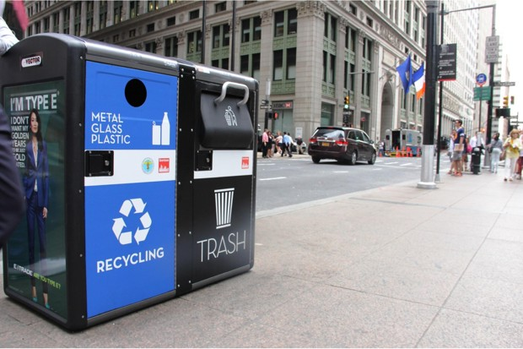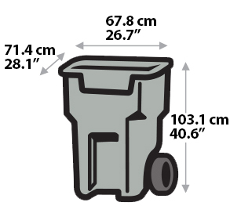

## 4.4 Angle measurement

The angle between the object and the ultrasonic sensor it’s not a problem because the garbage container is filled evenly.

Then it doesn’t matter where the sensor is placed.

# 5. External interface requirement

## 5.1 User Interface

In this section we are going to explain our Smartphone app’s user interface. This app will be responsible to detect when there are full garbage bins and show on map.

## 5.2 Graphical user interface

### 5.2.1 Start Screen

This is the main window when we open the app. We can see some buttons to choose the different windows and begin the function desire.

### 5.2.2 Map Screen

This is the window where the user can see every garbage bin and their state (empty or full)

### 5.2.3 Potential additions

If we mix this project with the application project, we will try to add more functionalities. This includes using an external database. We might then do a login system, with the user id’s and encrypted password stored, or a log of the garbage bin’s status history.

We would also make the application usable on both a tablet-sized screen and a phone-sized one.